
ediBroker Australia
Import of Commercial Invoice Data
from csv-file

© Eagle Datamation International Pty Ltd
• Level 2, 184 Bourke Road Alexandria NSW Australia
• Phone 61 2 9025 1100 • Fax 61 2 9025 1199 • training@edi.com.au

Table of Contents

1 Introduction 1
1.1 Important Remarks 1
1.2 Importing Organisation Data 2
2 File Specification 5
2.1 Generic Attributes of csv-Data Import Files 5
2.2 File Specification 5

Introduction

ediBroker allows import if Commercial Invoice data from a csv-file into a Customs Declaration. This document describes the standard file format for import of Commercial Invoice data for Australian sites.
The data can be imported from the Customs Declaration or Brokerage screen → Brokerage → Data → Import Invoices.

Important Remarks

It is essential that you strictly follow the file specification described in this document. If you would like to import Commercial Invoice data in a different file format, customer-specific programming will be necessary. This would be chargeable programming and require a quotation.

- Each Organisation in the csv-file will be added as a new record in ediEnterprise. The data import procedure will not merge any Organisations.

- Provide your current Organisation code in the csv-file, if possible. It will be then be stored on the Organisation → Config tab → Cntry <System Country>, Type “LSC = Legacy System Code” for further reference.

- If you want to bring across A/R and/or A/P Balances for the Organisations that you import from csv-file, provide an Organisation code. Otherwise the system cannot link the Balances to the Organisations and will not import the Balances.
- If Organisation data has been imported and you try to re-import the same Organisation data, the system will not load it. (N.B.: The system will verify whether an Organisation exists in ediEnterprise that has the same “Legacy System Code” = “LSC”.) The system will display all Organisations that have been excluded from the data import for this reason. The operator may print the list.
- If you import Organisations from multiple Data Sources, ensure that the Organisation codes are unique. It is suggested to use a pre-fix for each data source to achieve this.
Example:
You would like to import Organisation data from system 1 and 2 into ediEnterprise. System 1 has Organisation code “ABC001” for “ABC Company” in Sydney. System 2 also has Organisation code “ABC001” but it stands for “ABC Ltd. Pty.” in Singapore.
Import the Organisations from System 1 with the existing Organisation codes.
For the data import from system 2 add a pre-fix to the Organisation codes in the csv-file to make them unique, e.g. “2ABC001”.

Importing Organisation Data

On the Customs Declaration or Brokerage screen select Brokerage → Data → Import Invoices to import Commercial Invoice data from a csv-file as per file specification below.
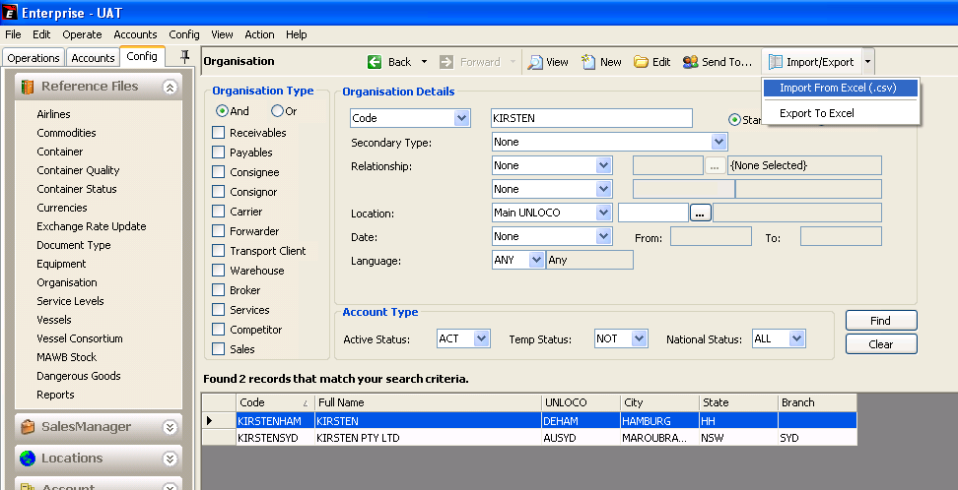

The system will prompt you:
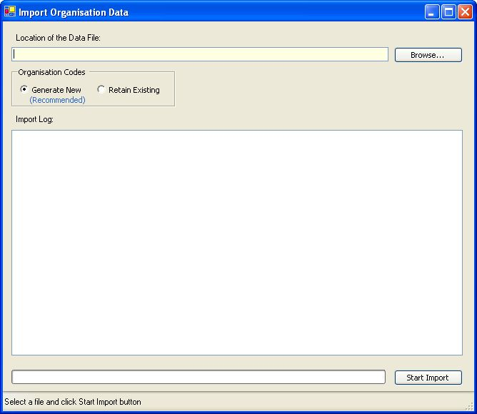

Option | Description
Location of the Data File | Enter the data-directory and file name.
Organisation Codes:
Generate New | - Recommended option -  Tick to create new Organisation codes using the ediEnterprise coding algorithm:  - first 3 characters of the first word and  - first 3 of the second word and  - last 3 characters of the Organisation’s Port code  For example “American Express International Pty Ltd” in AUSYD would be coded as “AMEEXPSYD”.
Retain Existing | Tick to keep the Organisation Codes provided in the file.  N.B. Organisation Codes for new Organisations entered in ediEnterprise will be coded as per new coding structure and will therefore differ.

Press the [Start Import] button to import the Organisation data.

System Prompt after pressing the <Start Import> button:
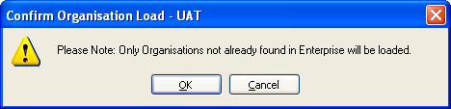

System Logging, if the File Header is incorrect:
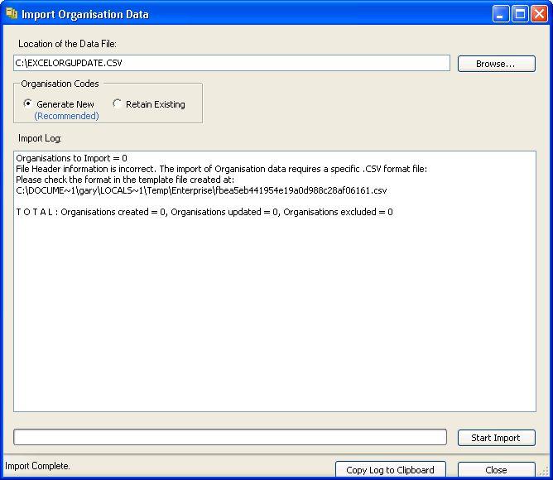
Open the sample csv-file created by the system. It shows the required file format and column headers.

System Logging showing errors that may occur:
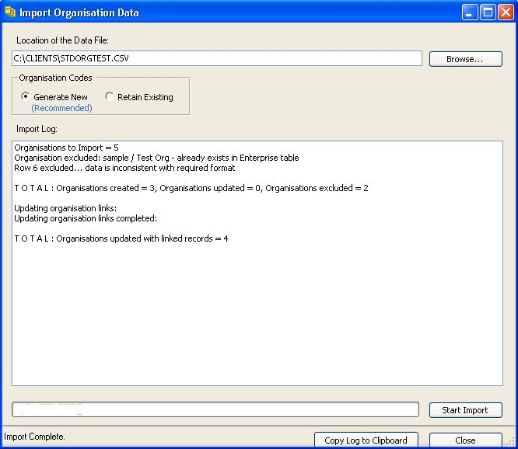

File Specification

Generic Attributes of csv-Data Import Files

The following applies to the standard ediEnterprise data import files in csv-file format:
- The file format is csv-file.
- The first line of the file must be the header line. It must contain the headers in exactly the same spelling as per file specification below. Otherwise the data will not be imported.
- It is essential that you provide all columns in the order as listed in the file specification. Do not add any additional columns or omit any columns. Otherwise the data will not import.
- Leave non-mandatory fields blank, if you cannot provide the data.
- Date fields are 8 characters in the form YYYYMMDD. No separators are allowed.
- Boolean fields are character “Y” = True or character “N” = False.
A blank boolean field is interpreted as “N”.
The system validates the header of each column to determine whether the file structure matches the standard. If the number of columns differs or the column headers are spelt differently, the data will not import.

If you haven’t already received a sample file, you are welcome to contact edi and request one.

File Specification
Legend:
Col Column
Type A = alphanumeric
N = numberic
B = Boolean
M = mandatory
C = Conditional

Invoice Header Record
Col | Field | Type | M | Remarks
 | Type | 4 A | ? | Fixed: “HEAD”
 | Invoice No | 20 A | ?
 | Order No | 20 A | ?
 | Invoice Date | Date | ? | Format: CCYYMMDDHHMMSS
 | Invoice Amount | 9.2 N | ?
- A | Invoice Currency ISO Code | 3 A | ?
- S | Inco Term | 3 A | ?
 | Preference | 3 A | ?
 | Related Y/N | 1 A | ?
 | Tax Exempt | 10 A | ?
 | Supplier Code | 12 A | ?
 | Supplier Name | 50 A | ?
 | Supplier Reg Number | 20 A | ?
 | Supplier Phone | 20 A | ?
 | Supplier Street 1 | 50 A | ?
 | Supplier Street 2 | 50 A | ?
 | Supplier City | 25 A | ?
 | Supplier Post Code | 10 A | ?
 | Supplier Country ISO Code | 2 A | ?
 | Buyer Code | 12 A | ?
 | Buyer Name | 50 A | ?
 | Buyer Reg Number | 20 A | ?
 | Buyer Phone | 20 A | ?
 | Buyer Street 1 | 50 A | ?
 | Buyer Street 2 | 50 A | ?
 | Buyer City | 25 A | ?
 | Buyer Post Code | 10 A | ?
 | Buyer Country ISO Code | 2 A | ?
 | CustomText1 | 20 A | ?
 | CustomText2 | 20 A | ?
 | CustomDate1 | Date | ? | Format: CCYYMMDDHHMMSS
 | CustomDate2 | Date | ? | Format: CCYYMMDDHHMMSS
 | CustomFlag1 | 1 A | ?
 | CustomFlag2 | 1 A | ?
 | CustomDecimal1 | 9.3 N | ?
 | CustomDecimal2 | 9.3 N | ?

Invoice Charges Record
Col | Field | Type | M | Remarks
 | Type | 4 A | ? | Fixed: “CHRG”
 | Charge Type | 3 A | ? | ADD Other Dutiable Charges  COM Commission  DED Other Non-Dutiable Charges  DIS Discount  EXW Ex Works Amount  FIF Foreign Inland Freight  LCH Landing Charges  OTH Other Charges  OFT Overseas Freight  ONS Overseas Insurance  PAC Packing Cost
 | Amount | 9.2 N | ?
 | Currency ISO Code | 3 A | ?
 | Duty Applicable Y/N | 1 A | ?
 | GST Applicable Y/N | 1 A | ?
 | Included in ITOT Y/N | 1 A | ?
 | Prepaid/Collect | 3 A | ? | PPD Prepaid  CLT Collect

Invoice Lines Record
Col | Field | Type | M | Remarks
 | Type | 4 A | ? | Fixed: “LINE”
 | Line N | int??? | ?
 | Invoice No | 20 A | ?
 | Order No | 20 A | ?
 | Product Code | 35 A | ?
 | ProductAttrib1 | 10 A | ?
 | ProductAttrib2 | 10 A | ?
 | ProductAttrib3 | 10 A | ?
 | Product Description | 350 A | ?
 | Invoice Quantity | 18.5 | ?
 | Unit of Quantity | 3 A | ?
 | Total Line Volume | 9.3 N | ?
 | Volume Unit of Qty | 3 A | ?
 | Total Line Weight | 9.3 N | ?
 | Weight Unit of Qty | 3 A | ?
 | Total Line Price | 18.4 N | ?
 | Tariff Code | 15 A | ?
 | Classification Lookup | 35 A | ?
 | Customs Quantity | 18.5 N | ?
 | Customs Unit of Qty | 3 A | ?
 | Origin Country ISO Code | 3 A | ?
 | Origin State | 3 A | ?
 | Treatment Code | 10 A | ?
 | Preference | 3 A | ?
 | Concession | 15 A | ?
 | CustomText1 | 20 A | ?
 | CustomText2 | 20 A | ?
 | CustomText3 | 20 A | ?
 | CustomDate1 | Date | ? | Format: CCYYMMDDHHMMSS
 | CustomDate2 | Date | ? | Format: CCYYMMDDHHMMSS
 | CustomDate3 | Date | ? | Format: CCYYMMDDHHMMSS
 | CustomFlag1 Y/N | 1 A | ?
 | CustomFlag2 Y/N | 1 A | ?
 | CustomFlag3 Y/N | 1 A | ?
 | CustomDecimal1 Y/N | 9.3 N | ?
 | CustomDecimal2 Y/N | 9.3 N | ?
 | CustomDecimal3 Y/N | 9.3 N | ?

